

Data Technician

Name: Kieran Parkin
Course Date: 22/09/2025
Table of contents
Day 1: Task 1 2
Day 2: Task 1 2
Day 2: Task 2 3
Day 2: Task 3 4
Day 3: Task 1 4
Day 3: Task 2 5
Dataset: 5
Step 1: Create a Pivot Table 5
Step 2: Use the SWITCH Function 5
Submission: 6
Day 3: Task 3 6
Day 4: Task 1 7
Course Notes 9
Additional Information 10

Day 1: Task 1

Please research and complete the below boxes on common laws and regulations that must be followed when working with customers data, use the below bulleted list to support your answers.

- What is it
- Why is it important
- Provide a real-world example of how you can follow it
- How does it impact working with data
- What could happen if you breached it

Data Protection Act | This is an act that controls personal information in the way that it is used by organisations. It is important as this stops people from being able to legally acquire and spread personal information and ensure data is handled fairly and securely.  You can follow the Data Protection act by keeping a vigilant eye on the kind of information people are trying to acquire for you, as someone could be maliciously gathering the data.  There are also companies that run fake Phishing emails to gather data from employees and to see who clicks on them without looking into it first. DPA impacts working with data as it means you must be a lot more careful to follow the act as the repercussions to breaching this act are severe.  An example of the repercussions would be the following: Yahoo! UK Services Limited were fined £250,000 by the ICO following a data breach in November 2014. This data breach encompassed 500 million Yahoo! users and witnessed the compromise of their personal data.
GDPR | The GDPR is an EU designated call that is designed to protect the personal data and privacy of a user. The regulation ensures that people's personal information is handled both lawfully and fairly. This is important as it strengthens the right of consumers and ensures the right to correct any information as well as to have it erased if that is what they desire.  A real-life example of this would be reviewing data that a third-party applicant is trying to take from you, as you are the one responsible for how your data is handled. This can be done from researching the company or even signing a GDPR compliance form if there is one there.  There are 2 penalties to not following these guidelines, which are the following:  a) Lower-tier fines: Up to 10 million euros or 2% of global annual revenue, whichever is higher, typically for breaches like record-keeping or data security failures.  b) Upper-tier fines: Up to 20 million euros or 4% of global annual revenue, whichever is higher, usually for serious violations such as unlawful data processing, denial of rights, or illegal data transfers.
Freedom of Information Act | This act gives a general right of access to all types of recorded information held by UK authorities. Rights to freedom under the Information Act became a thing from 2005 and with it comes the companies needing to let you know in writing whether they hold information you've requested and provide it if so and to respond to you within 20 working days.  Examples of information that can be requested would be documents and records, electronic data and multimedia and a real-life example of this would be when The FOI Act was used to uncover that the cost to police a single football match between Celtic and Rangers in the 2010/11 season was over £2 million, while the clubs only contributed £300,000.  I have found the following information regarding penalties with FOI:  section 77 states that it is a criminal offence to alter, block, destroy or conceal information. Depending on the nature of the incident, an authority or its individual members of staff could be charged with this offence. The penalty is a fine.  There are no financial or custodial penalties for failure to provide information on request or for failure to publish information. But you could be found in contempt of court for failing to comply with a decision notice, enforcement notice, or information notice. This could lead to a fine or, in theory, jail for a senior officer of the authority.
Computer Misuse Act | This is an act from 1990 that make it illegal to access someone’s computer without their permission or to make changes to it either. The act covers events such as hacking a device or maliciously damaging a machine through malware or viruses. Examples of penalties that could be in place for this would be dependent on the offense but could range from a fine to prison time. An example of this in real life would be in 2017 when two men were arrested for their plan to hack into Microsoft’s network.

Day 2: Task 1

Please research and complete the following tasks within the retail-sales_dataset.xlsx document, paste a print screen into the provided boxes below:

- In the sheet ‘retail_sales_dataset’ add all available data between columns A – J into a ‘Table’. Remember to select only the data you want to convert.
- Using the dropdown menu in the ‘Age’ column, sort the data by age, ‘largest to smallest’
- Using the ‘SUM’ function, show me the commission total in cell ‘M10’
- Using the ‘AVERAGE’ function, show me the average commission in cell ‘M11’

Print screen 1 | 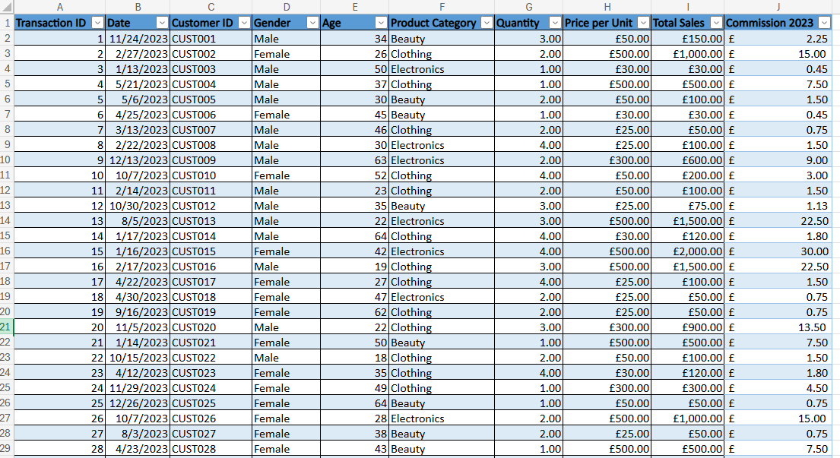
Print screen 2 | 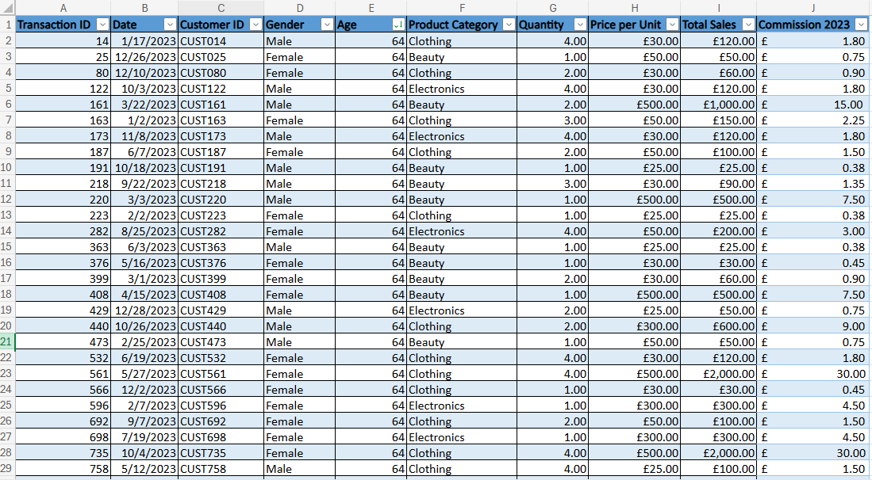
Print screen 3 | 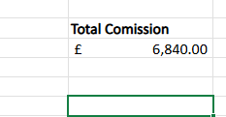
Print screen 4 | 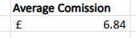

Day 2: Task 2

Please research and complete the following tasks within the retail-sales_dataset.xlsx document, paste print screens into the provided box below:

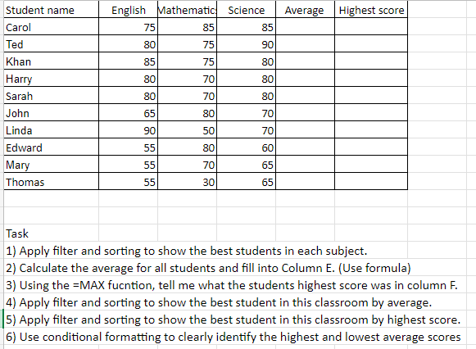

Print screen 1 | 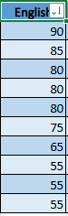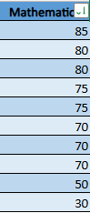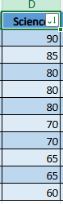  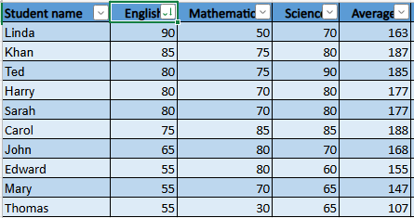  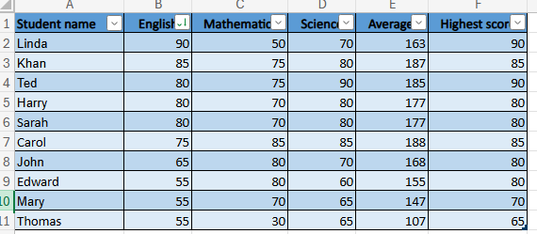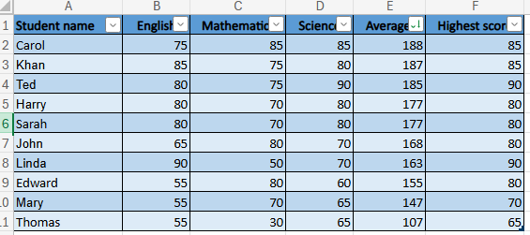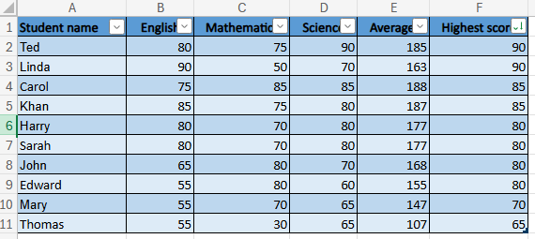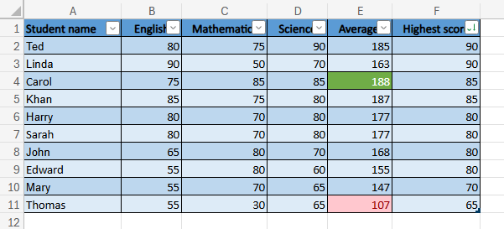

Day 2: Task 3

Using the skills developed today, have some fun with the data set you have imported. Paste your work below and enjoy!

Print screen 1 | 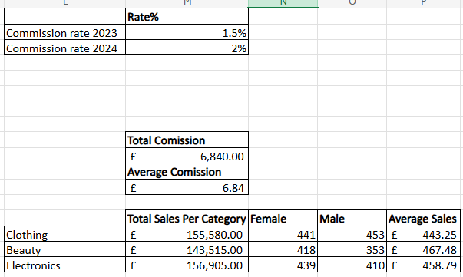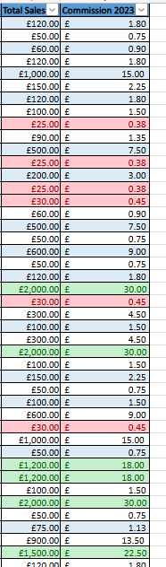

Day 3: Task 1

Please download the dataset ‘Day_3_Task_1_Bike_Sales_Pivot_Lab.xlsx’ from here.

The lab instructions can be found here. Do not worry if you do not complete the lab, just working with data and playing with the pivot table will be good experience.

Please paste your final pivot table below and complete the reflection questions:

Print screen 1 | 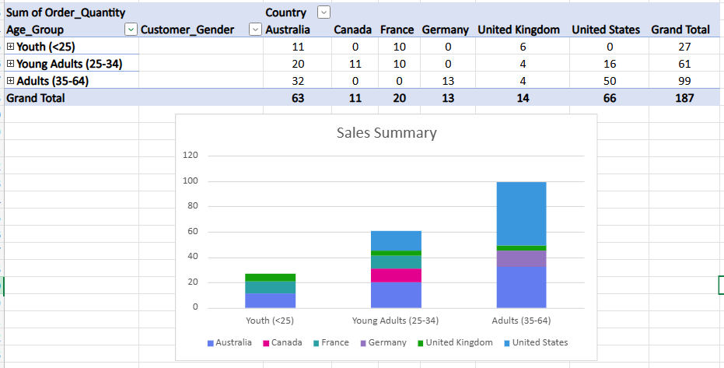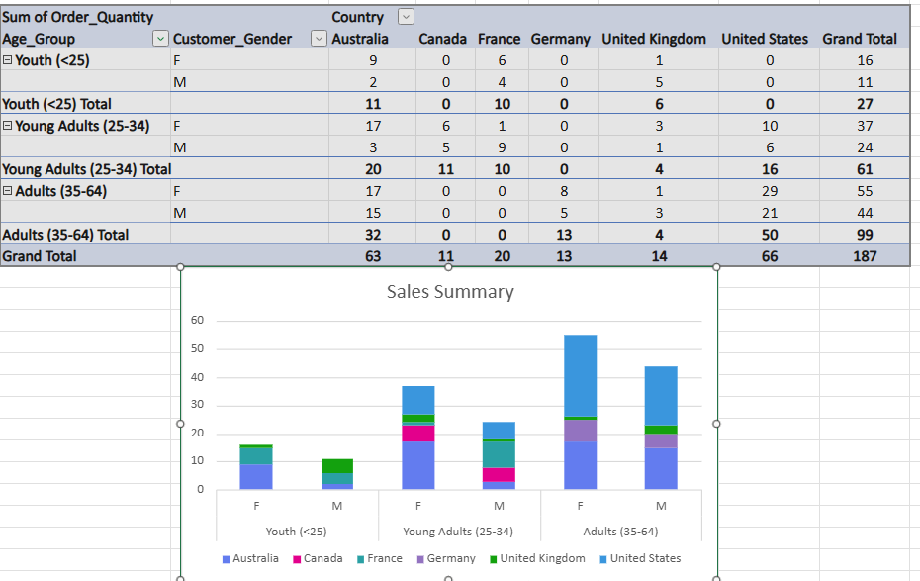
In which markets does Germany have customers? | The market for Germany is Adults aged 35-64 with a total of 13 orders.
What country has sales in all markets? | The United Kingdom has sales in all markets.
What are the most profitable markets by country, age group, and gender? | Country is United states with 66, age group is Adults aged 35-64 with 99. Gender with the most markets is Female with 108
Any other findings? | The data is a steady incline, meaning that as people get older, they seem more likely to order a bike.

Day 3: Task 2

The dataset below tracks the sales performance of different products in various counties in England. Please paste the dataset into a blank Excel workbook. Your task is to:
- Create a Pivot Table to summarise the data by county and product.
- Use the SWITCH function to categorise products based on their sales volume.

Dataset:
County | Product | Sales Volume
Yorkshire | Laptops | 500
Yorkshire | Smartphones | 200
Cornwall | Laptops | 700
Cornwall | Printers | 400
Lancashire | Smartphones | 150
Lancashire | Laptops | 600
Essex | Printers | 800
Essex | Smartphones | 300
Durham | Laptops | 250
Durham | Printers | 300
Greater Manchester | Smartphones | 600
Greater Manchester | Laptops | 400

Step 1: Create a Pivot Table
- Select the dataset (columns A to C).
- Insert a Pivot Table to summarise the data by County in the rows and Products in the columns. Use Sales Volume as the value to be summarised.

Step 2: Use the SWITCH Function
In a new column next to your data, use the SWITCH function to categorise products based on Sales Volume as follows:
  - For sales greater than 600: "High"
  - For sales between 300 and 600: "Medium"
  - For sales less than 300: "Low"
SWITCH Function Example:
=SWITCH(TRUE, C2 > 600, "High", C2 >= 300, "Medium", "Low")
- Apply this formula to each row, and check if the products are categorised correctly.
- In ‘Sales Volume’ you need to remove the space after each amount
- Confirm the data type is numerical

Submission:
- A completed Pivot Table summarising sales by county and product.
- A new column in the dataset categorising products by sales volume using the SWITCH function.
  - Please paste your completed work below

Print screen 1

Day 3: Task 3

Please download the dataset ‘Day_3_Task_3_Bike_Sales_Visualisations_Lab.xlsx’ from here.

The lab instructions can be found here. Do not worry if you do not complete the lab, just working with data and playing with the charts will be good experience.

Please paste your results below:

Print screen 1

Day 4: Task 1

You have been asked to deliver your analysis findings to the board of directors, within your analysis you have identified that customers are leaving your company at the 12-month point, this is typically when they receive their renewal price.

Conduct research and complete the below questions:

How would you prepare for the delivery?
What tools would you use for the delivery?
What is prospecting and why would you complete this before your delivery?
Tell me best practices for public speaking and providing updates to senior leaders
What will you show the board in your delivery?
How will you articulate the changes that are needed?
Provide a list of online resources and videos that will support your preparation for public speaking
Evaluate tools that provide visualisation.

Tell me what they are.

Tell me what you would choose when delivering your presentation and why

Course Notes

It is recommended to take notes from the course, use the space below to do so, or use the revision guide shared with the class:

Additional Information

We have included a range of additional links to further resources and information that you may find useful, these can be found within your revision guide.

END OF WORKBOOK

Please check through your work thoroughly before submitting and update the table of contents if required.

Please send your completed work booklet to your trainer.

